

KUBERNETES INSTALLATION
DevOps Certification Training

support@intellipaat.com
+91-7022374614
US: 1-800-216-8930(Toll Free)

INSTALLING KUBERNETES
Steps for Both Master and Slave

Step 1: Run the following commands for installing kubeadm as root
$ apt-get update
$ apt-get install docker.io
$ apt-get update && apt-get install -y apt-transport-https curl
$ curl -s https://packages.cloud.google.com/apt/doc/apt-key.gpg | apt-key add -
$ cat <<EOF >/etc/apt/sources.list.d/kubernetes.list
deb https://apt.kubernetes.io/ kubernetes-xenial main
EOF
$ apt-get update
$ apt-get install -y kubelet kubeadm kubectl

Steps for Kubernetes Master
Step 1: Initialize kubeadm using the following command:
$ kubeadm init –apiserver-advertise-address=<ip-address-of-master> --pod-network-cidr=192.168.0.0/16 --ignore-preflight-errors=NumCPU

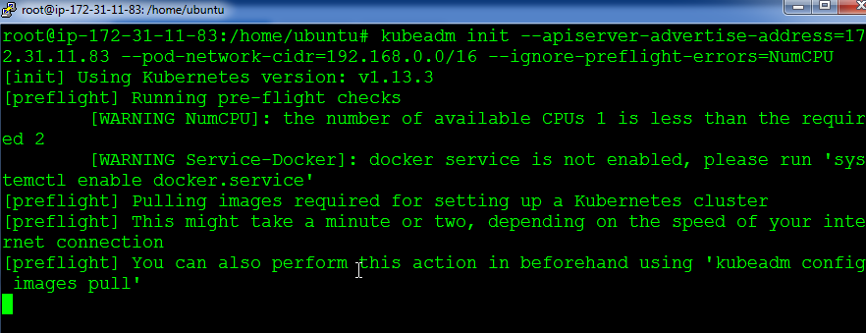

Step 2: In the output of the previous command, you will get a command, take this command and run it in the slave
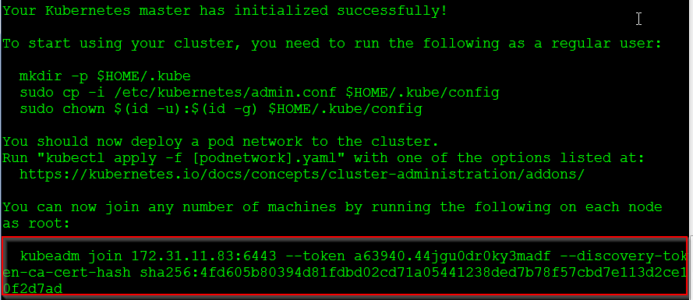
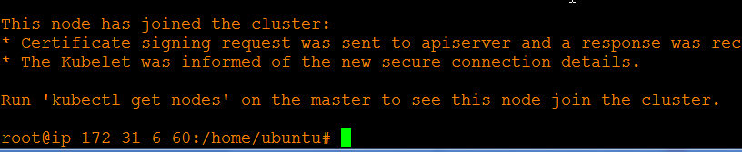

Step 3: On the master, exit to the normal user, and execute the following commands:
$ mkdir -p $HOME/.kube
$ sudo cp -i /etc/kubernetes/admin.conf $HOME/.kube/config
$ sudo chown $(id -u):$(id -g) $HOME/.kube/config

Step 4: Next, let’s install the network plugin. Execute the following commands:
$ kubectl apply -f https://docs.projectcalico.org/v3.3/getting-started/kubernetes/installation/hosted/rbac-kdd.yaml
$ kubectl apply -f https://docs.projectcalico.org/v3.3/getting-started/kubernetes/installation/hosted/kubernetes-datastore/calico-networking/1.7/calico.yaml

Step 5: The previous command will take some time to take effect. After 4-5 mins, try the following command, if both the nodes are in the ready state, Installation is successful!
$ kubectl get nodes

